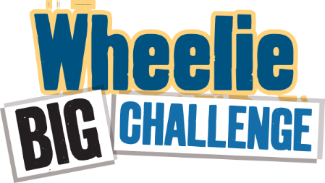

**Worksheet – School Waste Audit 1**

**Detailed Audit - What’s happening inside the school?**

**The aim of this task is to find out what is in your general waste bins that could be recycled.** You will need gloves, scales and perhaps a plastic sheet for this activity. Choose 3-5 small waste bins from a variety of areas (e.g. classrooms, office, ICT room, staff room) towards the end of the day**. Note you will audit the same bins for Audit 2**. Separate each bin into three categories: recyclable, non-recyclable, and food waste. Weigh each (in grams) and record in the chart below. (**Remember to save these results in your Data Zone!**)

|  |  |  |  |  |
| --- | --- | --- | --- | --- |
| **Location** | **Mixed Dry Recyclables**  (e.g. paper, card, plastic, yoghurt pots, tins) / **grams** | **Compostable Food**  (e.g. crusts, fruit, teabags)  / **grams** | **Non-Recyclable**  (e.g. wrappers, cling film, pens, straws, tissues)  / **grams** | **Overall weight**  (eg. everything in the bin)  / **grams** |
| **Bin 1 from:** |  |  |  |  |
| **Bin 2 from:** |  |  |  |  |
| **Bin 3 from:** |  |  |  |  |
| **Bin 4 from:** |  |  |  |  |
| **Bin 5 from:** |  |  |  |  |
| **Total weight** |  |  |  |  |
| **Percentage** | _________% | _________% | _________% | 100% |

**To complete your bin audit, check your single-use plastic items!**

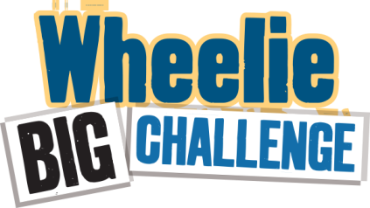From the mixed dry recyclables and the non-recyclable items, select the ones in the table below that are single-use and count how many of each item you can find.

**THE CHALLENGE FOR YOUR SECOND AUDIT WILL BE REDUCING THE NUMBER OF SINGLE-USE ITEMS…WHO WILL WIN?**

|  |  |  |  |  |  |  |  |  |  |
| --- | --- | --- | --- | --- | --- | --- | --- | --- | --- |
| **Item** | Cups | Cutlery (knives, forks, spoons, stirrers) | Straws | Food packaging | Yogurt Pots | Plastic bottles | Cling film | Plates | Lids |
| **Number** |  |  |  |  |  |  |  |  |  |

**YOU ARE READY TO SIGN YOUR PLASTIC PROMISE HERE**

<https://www.liveherelovehere.org/cgi-bin/PlasticPromiseMakeYourPromise>

**Simple Audit - What’s happening outside?** Investigate what bin collection system your school uses.

Who is your Waste Service Provider? (It may say on the outside bins) _____________________________

How often are they emptied? ________________________________

**Take a sneak peek.** What’s in the waste/landfill bins? Can you see recyclable items in there? List any that you see:

**Waste actions**

Now that you have done your initial audit it is time for you to consider what you could do to improve the waste situation at your school. If you have no recycling in place, or you think you could do better, this is a great opportunity to make a massive difference to the school’s environmental record and save some money – remember recycling bins will cost less than waste bins, and reducing waste production will even be better! 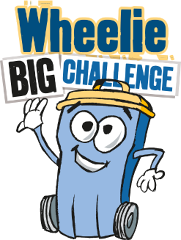

Your bins are probably already being collected by the council. Contact them to exchange a waste bin for a recycling bin or to double check what exactly can go into your recycling bins. As time goes on you may find you need more recycling bins than waste bins – think of the money you could be saving!

**Improving things inside the school.**

If your audit of inside bins showed that not everything is being recycled as it should be, what can you do to improve the situation? Here are a few ideas

* Hold an assembly reminding everyone what they need to do and why.
* Improve signage – do people know what goes in which bins?
* Raise awareness about general waste and plastic waste through a poster competition.
* Is there a lot of food waste in lunch boxes? Send it home. Educate about packing or taking only what you will eat.
* Consider using Terracycle and SchoolCycle for items like crisp packets
* Prizes for the best recyclers – which classrooms pass the sneak peek test?
* Assign bin monitors in each class to keep everyone right.
* More bins – even labelled boxes would do for paper and plastic recycling.
* Are you filling your waste wheelie bins all the way? You get charged per lift.
* Why not plan a Plastic Free 2-week challenge? Can you do a Plastic Free Month?
* Challenge all students and staff to go one week without bringing single-use plastic to school (including water bottles, coffee cups, and items in their lunch and snack!).
* Approach the canteen to reduce plastic
* Help a school event to go plastic free
* Set SMART (Specific, Measurable, Achievable, Relevant, Time-bound) goals (e.g. aim for every student in P6 or in Y10 to use a reusable water bottle by the end of the year) – it can help you to track your progress as you go.

**Useful contact numbers for help and advice –**Eco-Schools – 028 9073 6920 or email: [eco-schools@keepnorthernirelandbeautiful.org](mailto:eco-schools@keepnorthernirelandbeautiful.org)